1.FIND SUM,AVERAGE AND PRODUCT OF FOUR INTEGERS:

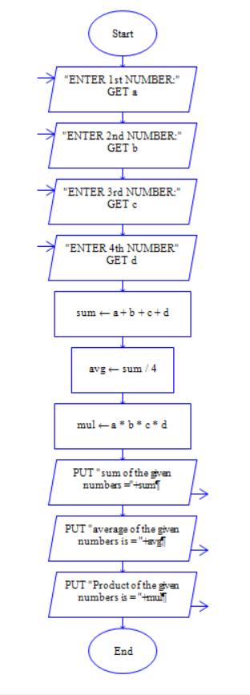

2.TO EXCHANGE THE VALUE OF TWO VARIABLES:

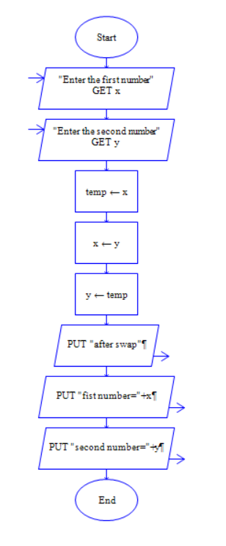

3.TO ASK YOUR NAME,PROGRAM NAME AND ENROLLMENT NUMBER AND PRINT IT ON SCREEN:

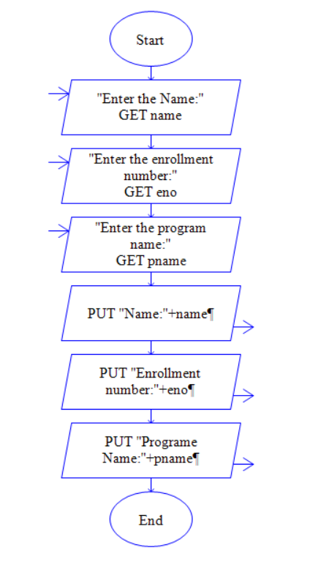

4.TO REVERSE THE DIGITS OF THE FIVE DIGIT INTEGER:

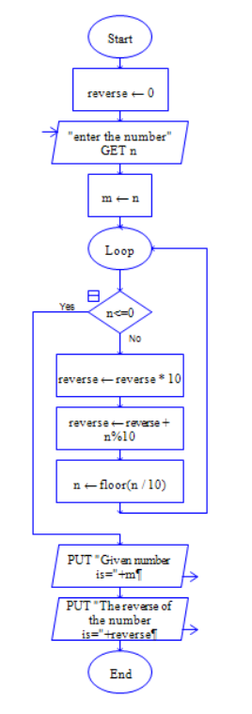

5.PROGRAM TO ADD,SUBTRACT AND MULTIPLY THE TWO GIVEN NUMBERS:

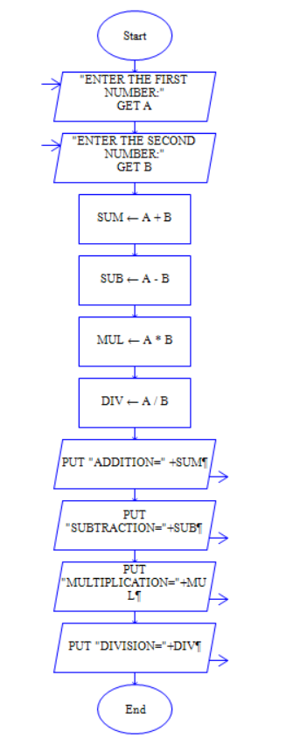

6.TO SOLVE QUADRATIC EQUATION:

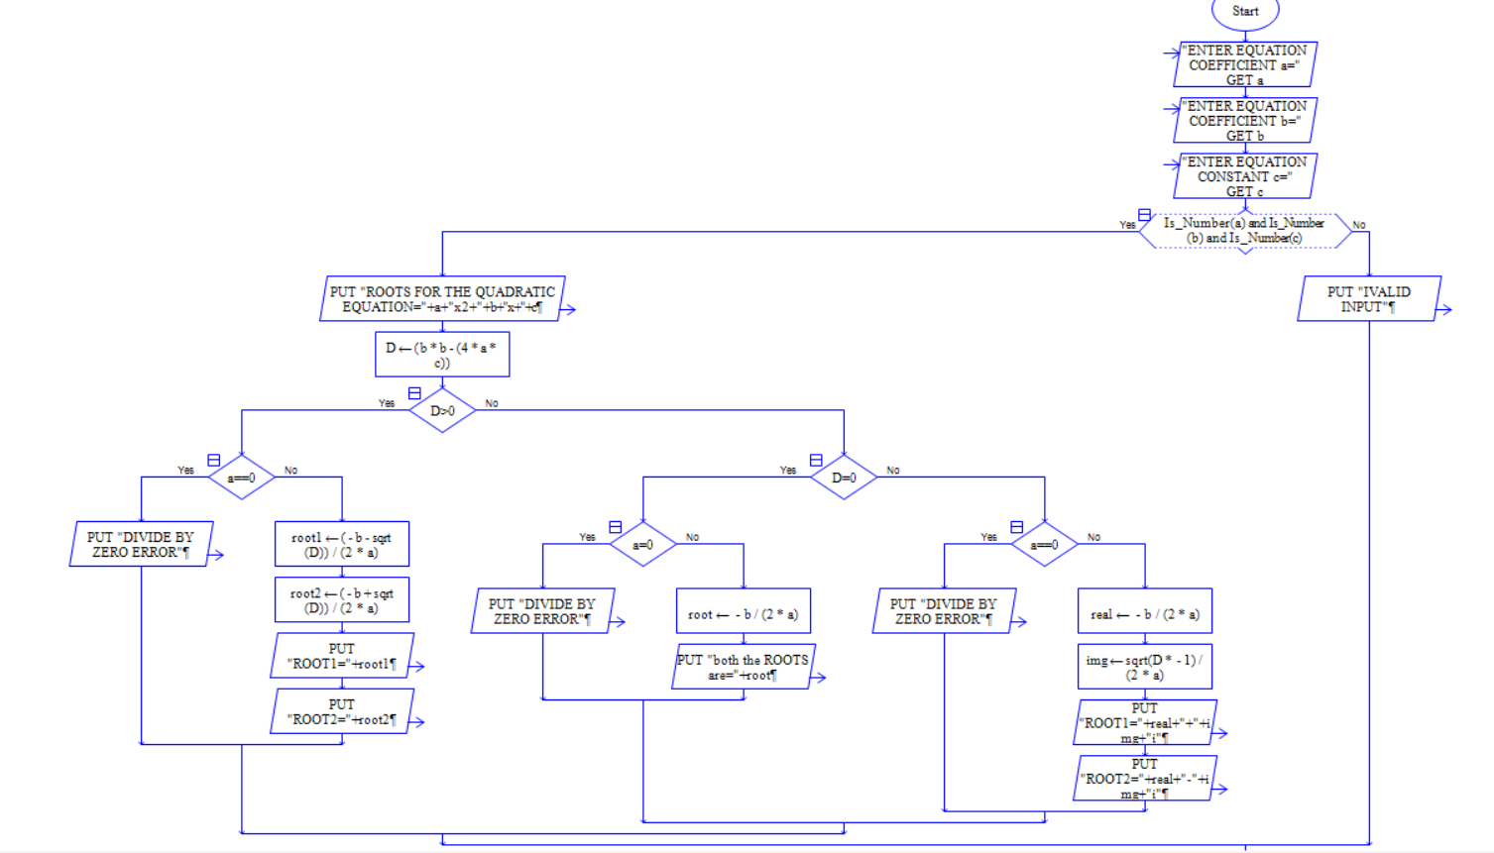

7.